Managing Individual Standards Pages

The individual standards pages use two sections of the basic template, the “Normal” section and the “Right” section. A sample page has been created, which can be copied to create new pages.

## How to rename a page

1. Click on the page in the page tree, then click the edit button

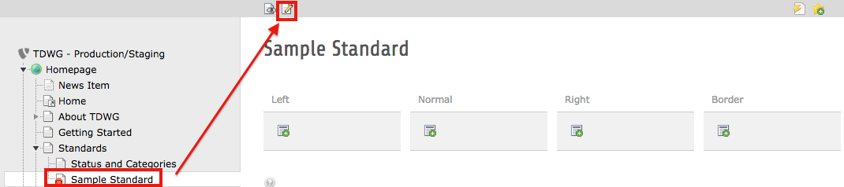

1. Enter the page title. If you want the page name to be different in the breadcrumbs and the left navigation on the live site, enter the name in the “Alternative Title” field.

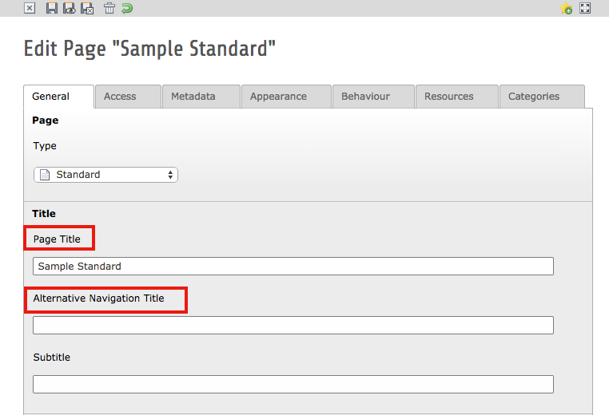

1. Save your changes

## How to enter the Outline and Abstract

Following are the steps for entering the outline and abstract if you are creating an entirely new page. If you’ve copied the page, you can either edit the existing text, or delete the existing elements entirely and create new ones following these instructions. The outline and abstract are located in the “Normal” column of the template.

### Outline

The outline section is a regular text element

1. Enter the header
2. Choose “Layout 1” for the type
3. Enter the text for the outline using a bulleted list

### Divider

The divider is a special element

1. Choose the “Special Element” tab
2. Choose the “Divider” option
3. You can give it a name if you like (i.e. “Divider”)

### Abstract

The abstract section is a regular text element.

1. Enter the header
2. Choose “Layout 2” for the type
3. Enter the text for the abstract

## How to add a box to the sidebar

Follow the instructions for [Sidebar Boxes](https://docs.google.com/a/infielddesign.com/document/d/1yw74k7BwdbbaByqnFASpRjoDjsLpCjb3r-U_4_pVX2U)